**3.6 I can select and use different elements to control environments for collaborative technologies**

There are a number of what are known as FCK editors available which can be used to edit/ replicate text and other html features including images. One of the more convenient are those that are based online and require no download, such as <https://nightly.ckeditor.com/22-02-16-07-04/standard/samples/>.

Here, you can change between seeing the source HTML code and the result using the *Source* button

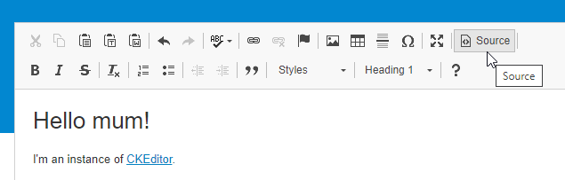

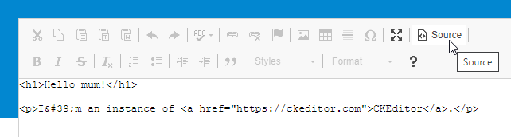

You can further add images and links by clicking the relevant button on the editor, which brings up a small window for you to add and adjust dimensions there and then.

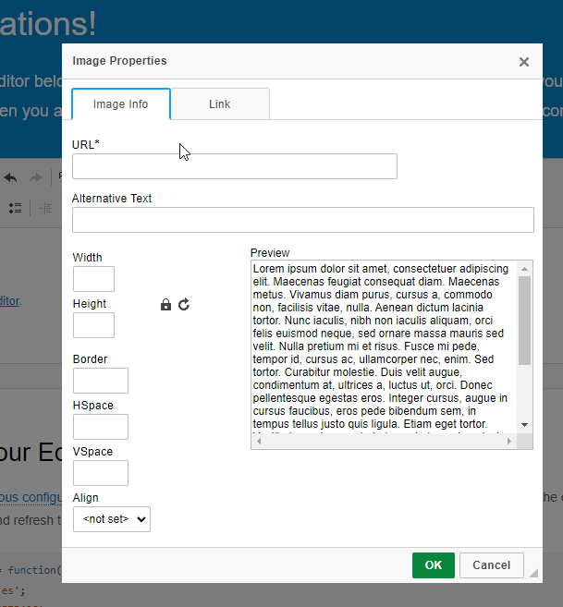 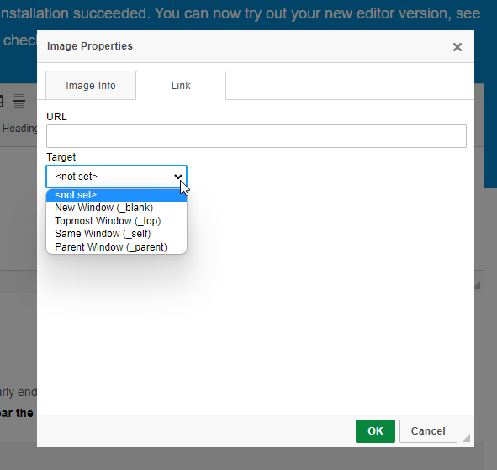

It is very easy to take text from elsewhere and to add it to the editor

